
INTERNSHIP REPORT WEEK 1
AGRA METRO PASSENGER DEMAND FORECASTING


SUBMITTED BY :- PRIYANKA ARORA
9149113191
Submitted To
Yuva Intern
on
AUGUST 1, 2026

Week 1 Report: Agra Metro Passenger Demand Forecasting Using Data Science and Python

Introduction
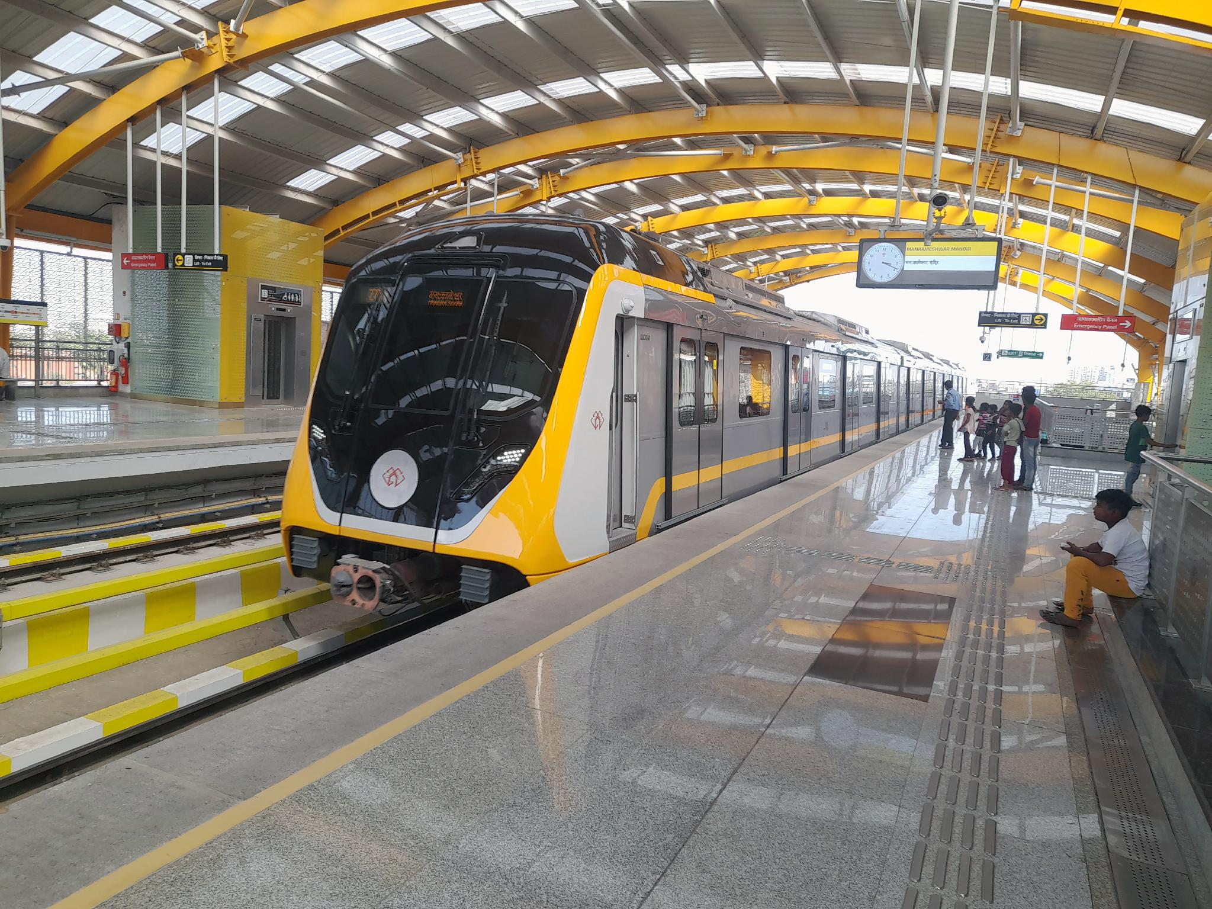
Agra Metro is a modern urban transportation system developed to provide safe, fast, and convenient travel for residents and tourists in Agra. It connects important locations such as Taj East Gate, Shaheed Captain Shubham Gupta, Fatehabad Road, Taj Mahal, Agra Fort, and Mankameshwar Mandir. Passenger demand varies throughout the day due to weekdays, weekends, public holidays, festivals, weather conditions, and tourist seasons. Therefore, accurate demand forecasting is essential for efficient train scheduling, resource allocation, and smooth metro operations.
This report presents a hypothetical project plan for forecasting passenger demand at Agra Metro stations using Data Science and Python. The objective of this report is to design a structured approach for solving the problem rather than implementing it. No real dataset or coding has been used. Instead, the report outlines the proposed data collection strategy, project methodology, tools and technologies, workflow, expected outcomes, and potential challenges. This planning framework demonstrates how data science can support informed decision-making and improve the operational efficiency of Agra Metro.

Project Background
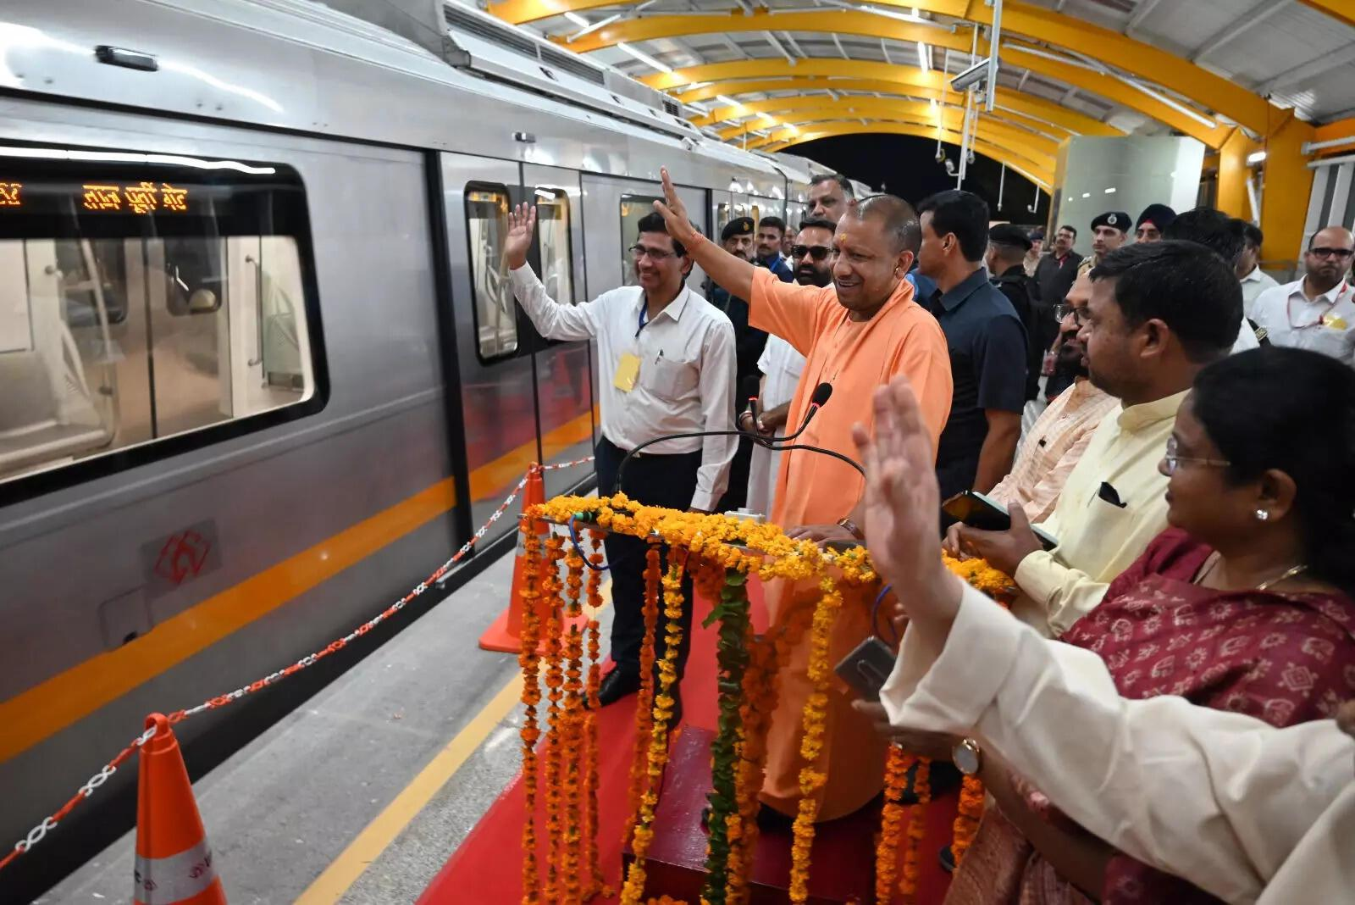
Agra Metro is a public transport system that helps people travel safely and quickly across the city. The currently operational priority corridor connects stations such as Taj East Gate, Shaheed Captain Shubham Gupta, Fatehabad Road, Taj Mahal, Agra Fort, and Mankameshwar Mandir.
At present, the metro corridor covers only a limited part of the city and does not connect many of Agra's busiest residential and commercial areas. Because of this, passenger numbers are lower and vary from one station to another. Demand is also affected by weekends, public holidays, festivals, weather conditions, and the number of tourists visiting places like the Taj Mahal.
This project aims to develop a planning framework for forecasting passenger demand using Data Science and Python. By estimating passenger demand in advance, the metro authority can plan train schedules, manage staff more efficiently, and make better operational decisions as the metro network grows in the future.

Project Observations and Recommendations
During the planning of this hypothetical project, the following observations were made:
- Agra Metro is the city's first metro rail project. The currently operational priority corridor mainly connects tourist locations and selected areas of the city. As the network is still expanding, passenger demand may be lower than expected at some stations.
- The second corridor under development is expected to connect more residential, commercial, and high-traffic areas. Once operational, it may increase the overall number of metro passengers and improve connectivity across the city.
- Current operations can be optimized based on passenger demand. If future passenger data shows consistently low ridership during certain days or time periods, the metro authority may consider adjusting train frequency or operating schedules. For example, running fewer services during low-demand periods or adopting an alternate-day or reduced-frequency schedule could help reduce operational costs while maintaining essential services. Such decisions should always be based on detailed passenger demand analysis and operational requirements.
These observations highlight how data-driven planning can help improve resource utilization, reduce unnecessary operational expenses, and provide better services as the Agra Metro network continues to grow.

Objectives
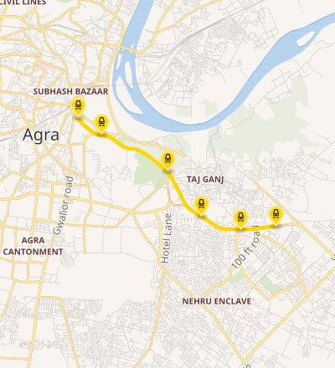
The main objectives of this project are:
- To design a data science framework for forecasting passenger demand at Agra Metro stations.
- To study the factors that may affect passenger demand, such as station location, weekdays, weekends, public holidays, weather conditions, and tourist activity.
- To propose a data collection and analysis strategy using Python for passenger demand forecasting.
- To help the metro authority plan train schedules and staff allocation based on predicted passenger demand.
- To identify opportunities for improving operational efficiency and reducing unnecessary operational costs.
- To support future decision-making as the Agra Metro network expands to other parts of the city.
.

Scope
In Scope
This project focuses on planning a data science solution for forecasting passenger demand at Agra Metro stations. The scope includes:
- Understanding the business problem.
- Identifying the required data sources.
- Planning the data collection process.
- Designing a data cleaning and analysis strategy.
- Proposing a machine learning approach using Python.
- Preparing a project timeline and workflow.
- Suggesting possible recommendations based on the predicted passenger demand.
Out of Scope
The following activities are not included in this project:
- Collecting real passenger data.
- Writing Python code.
- Training or testing machine learning models.
- Deploying the model in a live metro system.
- Developing a mobile or web application.

Assumptions
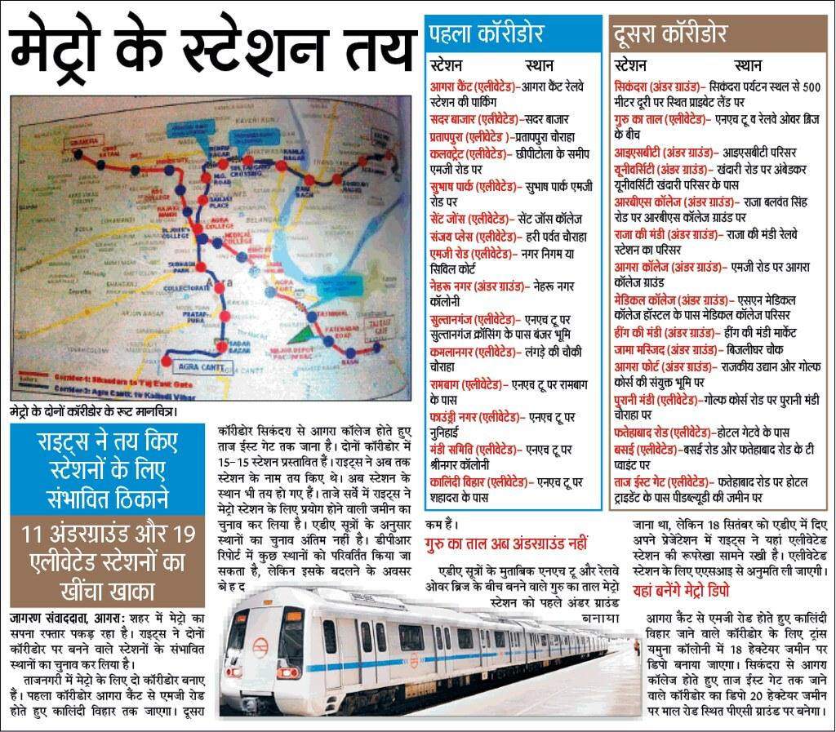
Since this is a hypothetical project, the following assumptions have been made:
- Historical passenger data for all Agra Metro stations is available.
- Information such as date, time, station name, ticket entries and exits, weather conditions, weekends, public holidays, and tourist seasons is available for analysis.
- The collected data is accurate, complete, and suitable for planning purposes.
- Python and the required libraries are available for data analysis and forecasting.
- The proposed forecasting model will be used only to support decision-making and improve operational planning.

Data Collection Plan

Since this is a hypothetical project, it is assumed that the required data will be collected from the following sources:
Data Source | Purpose
Automatic Fare Collection (AFC) System | To collect station-wise passenger entry and exit records.
QR Ticketing System | To understand ticket bookings and travel patterns.
Weather Data | To study the impact of temperature, rainfall, and other weather conditions on passenger demand.
Holiday and Festival Calendar | To analyze how public holidays and festivals affect metro usage.
Tourism Data | To estimate the impact of tourist arrivals, especially near the Taj Mahal and other tourist attractions, on passenger demand.
Metro Operations Data | To understand train schedules, service frequency, and operational planning.
The collected information will help in understanding passenger travel patterns and designing a suitable forecasting strategy. Since this is a planning-based project, no real data will be collected or analyzed in this phase.

Methodology
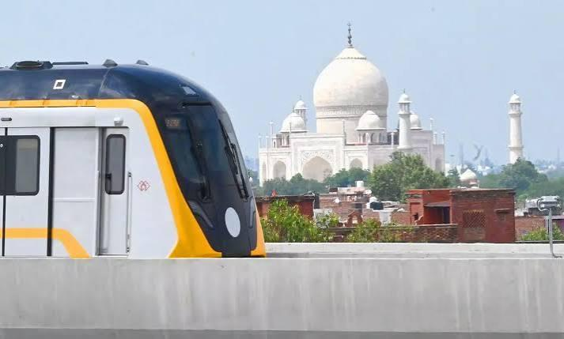The project will follow a structured data science approach to plan the passenger demand forecasting system for Agra Metro.
Step 1: Business Understanding
The first step is to understand the business problem, identify the project goals, and determine how passenger demand forecasting can help improve train scheduling, staff allocation, and overall metro operations.
Step 2: Data Collection
The required data sources, such as passenger records, weather information, holidays, tourism data, and metro operational data, will be identified for future analysis.
Step 3: Data Cleaning
A strategy will be prepared to remove duplicate records, handle missing values, and organize the data into a clean and consistent format.
Step 4: Exploratory Data Analysis (EDA)
A plan will be created to study passenger travel patterns, identify trends, compare weekday and weekend travel, and understand the factors affecting passenger demand.
Step 5: Feature Engineering
Useful features such as day of the week, holiday indicator, weather conditions, tourist season, and station location will be identified to improve the forecasting model.
Step 6: Model Selection
Suitable forecasting algorithms, such as Linear Regression, Random Forest, or other machine learning models, will be evaluated during the implementation phase. The most appropriate model will be selected based on the project requirements.
Step 7: Evaluation Planning
A plan will be prepared to evaluate the forecasting model using suitable performance measures to ensure accurate and reliable predictions.
Step 8: Recommendations
Based on the proposed forecasting results, recommendations will be made to improve train scheduling, staff deployment, and operational planning for Agra Metro.
Proposed System Architecture
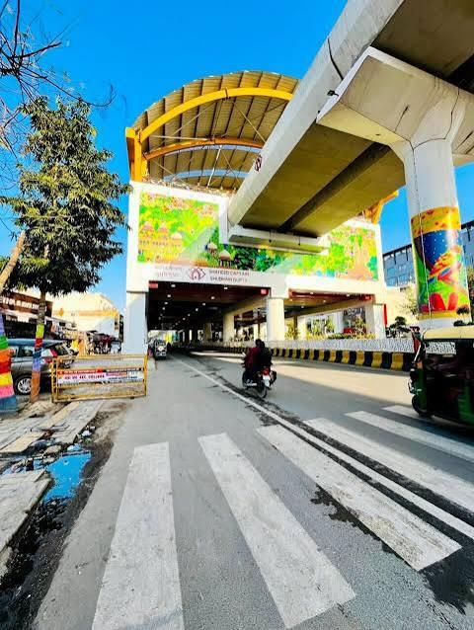
The proposed system architecture describes how the passenger demand forecasting system is planned to work.
Passenger Data Weather Data Tourism Data Holiday Data
│ │ │ │
└─────────────────┴─────────────────┴─────────────────┘
│
▼
Data Collection
│
▼
Data Cleaning & Preparation
│
▼
Exploratory Data Analysis (EDA)
│
▼
Feature Engineering
│
▼
Proposed Machine Learning Model
│
▼
Passenger Demand Forecast
│
▼
Business Recommendations & Operational Planning
Explanation
- Data Collection: Gather passenger, weather, tourism, and holiday information.
- Data Cleaning: Remove duplicate records and handle missing values.
- EDA: Analyze travel patterns and identify factors affecting passenger demand.
- Feature Engineering: Create useful features such as day of the week, holiday indicator, weather conditions, and station location.
- Proposed Machine Learning Model: Select a suitable forecasting algorithm during the implementation phase.
- Passenger Demand Forecast: Estimate future passenger demand for different metro stations.
- Business Recommendations: Use the forecast to support train scheduling, staff allocation, and operational planning.
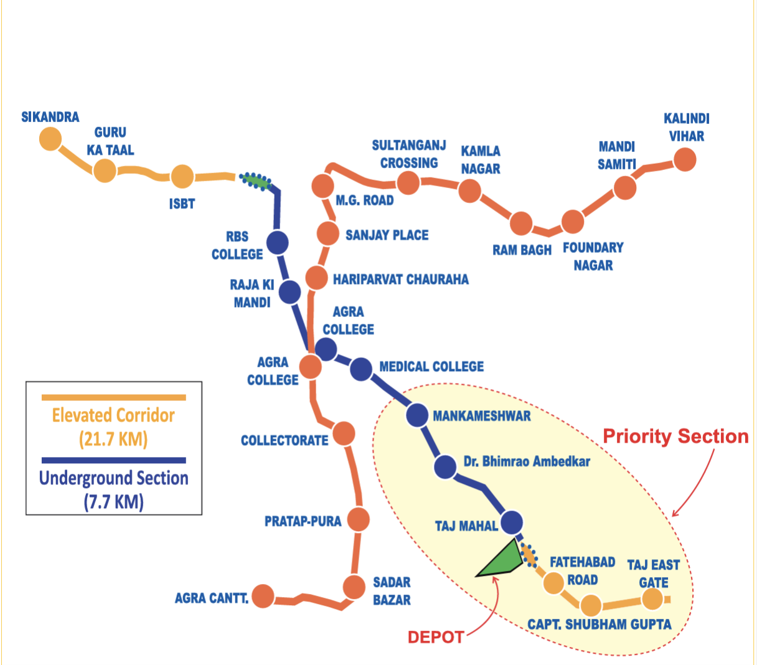

Project Timeline (35 Hours)
The estimated time required to complete the project planning is approximately 35 hours.
Activity | Estimated Hours
Business Understanding | 3 Hours
Requirement Analysis and Project Planning | 4 Hours
Data Source Identification | 4 Hours
Data Collection Strategy | 4 Hours
Data Cleaning and Preparation Planning | 4 Hours
Exploratory Data Analysis (EDA) Planning | 5 Hours
Feature Engineering and Model Selection Planning | 4 Hours
Evaluation Strategy and Recommendations | 3 Hours
Documentation and Report Preparation | 4 Hours
Total | 35 Hours
The project plan is designed to be completed over 35 hours. During this time, the focus will be on understanding the business problem, identifying suitable data sources, planning the data science workflow, selecting appropriate tools and techniques, and preparing the final project report. Since this is a planning-based assignment, no actual coding, model training, or deployment will be carried out during this phase.

Expected Outcomes
The proposed project is expected to:
- Improve train scheduling.
- Support better staff allocation.
- Enhance operational planning.
- Reduce unnecessary operational costs.
- Improve passenger travel experience.
- Support future data-driven decision-making.

Challenges
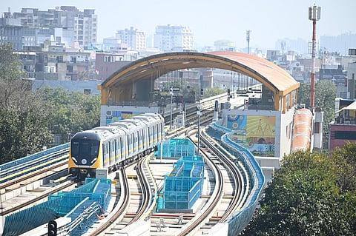
- Limited or no historical passenger data, as Agra Metro is a newly operational system.
- Difficulty in estimating passenger demand during the initial phase.
- Changes in passenger travel patterns as new metro corridors become operational.
- Dependence on external factors such as holidays, weather, and tourist visits.

Conclusion
This report presents a structured project plan for forecasting passenger demand at Agra Metro stations using Data Science and Python. It focuses on project planning, data collection strategy, methodology, tools, timeline, and expected outcomes. The proposed framework can serve as a foundation for future implementation when sufficient passenger data becomes available.

